|  |  |
| --- | --- |
| **Healthcare Provider Billing & Cost Analysis**  **Power bi project** | Abstract  This project explores how healthcare providers manage billing, treatment costs, and patient visits. Using Power BI, I analyzed a large dataset to uncover patterns in departmental spending, insurance coverage, and patient demographics. The goal was to build a dashboard that helps hospitals make better decisions and improve financial efficiency.  shadin k |

**Project Goal**

To build a dashboard that helps healthcare providers understand:

* Where their money is going
* Which departments and procedures cost the most
* How patients are paying (insurance vs. out-of-pocket)
* What trends exist in patient visits and demographics

**Objectives**

* Clean and organize raw visit data from a large .csv file
* Break down costs like treatment, medication, and room charges
* Analyze patient behavior based on age, gender, and race
* Compare performance across departments and procedures
* Visualize everything in Power BI for easy decision-making

**Dataset Overview**

The main dataset I used for this project is a large .csv file named visits.csv, which serves as the **fact table** in the Power BI model. It contains detailed records of patient visits to various healthcare departments, including billing information, treatment details, and demographic data.

**Size & Structure**

* **File Type**: CSV
* **Approximate Rows**: Tens of thousands (exact count depends on filters applied)
* **Columns**: 15+ fields covering patient info, visit details, costs, and location

**Key Columns & What They Represent**

* **VisitID**: Unique identifier for each patient visit
* **PatientID**: Identifier linking visits to individual patients
* **VisitDate**: Date of the visit, used for time-based analysis
* **Department**: Medical department visited (e.g., Orthopedics, Cardiology)
* **Procedure**: Type of procedure performed (e.g., MRI, Blood Test)
* **Diagnosis**: Medical condition diagnosed during the visit
* **BillingAmount**: Total amount billed for the visit
* **TreatmentCost**: Cost of medical treatment excluding other charges
* **MedicationCost**: Cost of prescribed medications
* **RoomCharges**: Charges for hospital room or stay
* **InsuranceCover**: Amount covered by insurance
* **OutOfPocket**: Amount paid directly by the patient
* **City**: Location of the hospital or clinic
* **Race, Gender, Age**: Patient demographic information

**Data Cleaning Steps**

Before building the dashboard, I cleaned the raw data using Power Query in Power BI. Here's what I did:

* **Removed extra columns** that weren’t useful for analysis.
* **Fixed missing values**, like blank gender or billing amounts.
* **Removed duplicate rows** to avoid counting the same visit twice.
* **Standardized text**, like making sure “female”, “F”, and “f” all became “Female”.
* **Corrected date formats** so I could filter by month and year properly.
* **Recalculated totals** where billing amounts didn’t match the sum of treatment, medication, and room charges.
* **Organized the data into tables** so it was easier to build visuals and apply filters.

**Data Model Overview**

I created a data model in Power BI with visits as the main table. It connects to other tables like patients, departments, procedures, and dates. Most tables are directly linked to visits, except for city, which is connected through the patients table. This setup helped me organize the data clearly and build a dashboard that’s easy to filter and analyze.

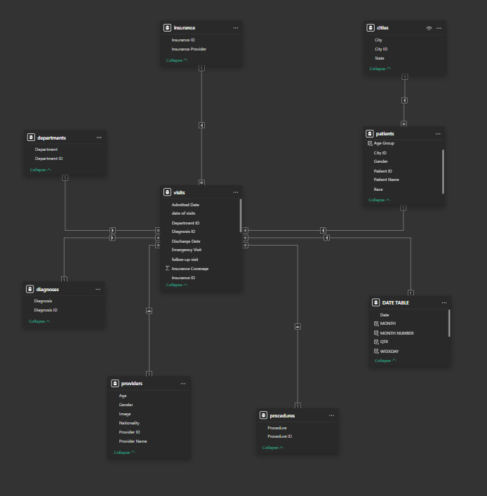

**Use of DAX in the Dashboard**

To make the dashboard more interactive and insightful, I created several DAX measures in Power BI. These helped me calculate totals and averages for key cost-related fields, and allowed the visuals to update based on filters like department, date, or patient demographics.

Here are the main DAX measures I used:

**Total Measures**

* **Total Medication Cost**
* **Total Treatment Cost**
* **Total Insurance Coverage**
* **Total Room Charges**
* **Total Billing Amount**
* **Total Out-of-Pocket**

These helped me understand how much was being spent or covered across different areas of healthcare.

**Average Measures**

* **Average Medication Cost**
* **Average Treatment Cost**
* **Average Insurance Coverage**
* **Average Room Charges**
* **Average Billing Amount**
* **Average Out-of-Pocket**

These gave me a clearer picture of cost per visit and helped compare departments and procedures more fairly.

Using DAX allowed me to build visuals that respond to filters and show accurate summaries — which made the dashboard more useful for decision-making

**Dashboard Overview**

I created a Power BI dashboard with three main pages to help understand healthcare visit data. Each page shows different types of information:

**Page 1: Cost and Billing**

* Shows total and average costs for treatment, medication, room charges, and billing
* Breaks down payments by insurance and out-of-pocket
* Includes filters for month, race, city, and state

**Page 2: Patient Details and Visit Trends**

* Shows visits by gender, age group, and race
* Tracks how visits change month by month
* Helps see which types of patients visit most often

**Page 3: Department and Procedure Analysis**

* Shows which departments and procedures have the highest billing
* Highlights common procedures like blood tests and X-rays
* Compares average treatment costs across emergency, inpatient, and outpatient services

The dashboard is easy to use and helps explore the data from different angles. It supports better decisions for hospital planning and cost management.

**Page 1: Financial Summary**

This Power BI dashboard showing total and average costs, billing breakdowns, and payment types.

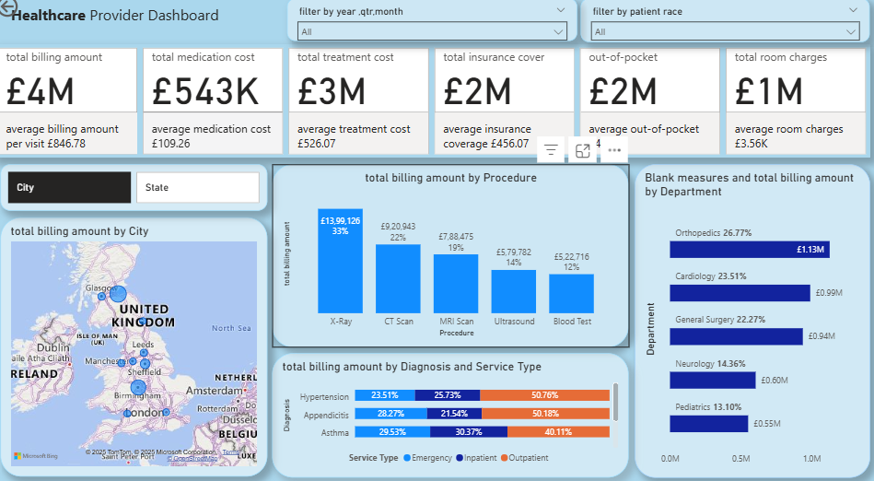

**Insights:**

* The total billing is around £4 million, and the average cost per visit is about £846.
* Room charges are almost as high as treatment costs, which means staying in the hospital adds a lot to the bill.
* Insurance and out-of-pocket payments are nearly equal, so patients are paying a big part of their bills themselves.
* Billing amounts are different across cities, which could be because of hospital size or local pricing.
* Some departments and diagnoses have much higher costs, especially Orthopedics and Cardiology.

**Page 2: Patient Details & Visit Trends**

This Dashboard page showing visits by gender, age group, race, and monthly patterns.

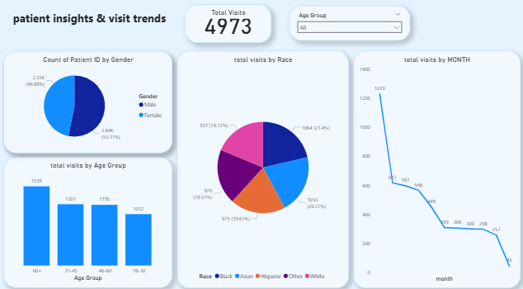

**Insights:**

* More male patients visited than female — about 57% male and 43% female.
* Most visits came from people aged 18–30, which might be due to common health checks or injuries.
* The largest racial groups in the data are White and Asian.
* January had the highest number of visits, and the numbers dropped slowly each month. This could be because of seasonal health issues or insurance renewals.

**Page 3: Department & Procedure**

This dashboard page showing billing by department, procedure types, and average treatment costs.

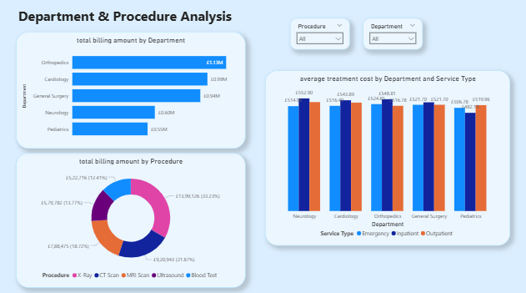

* Orthopedics, Cardiology, and General Surgery had the highest billing totals.
* Blood tests, X-rays, and CT scans were the most expensive procedures overall.
* Emergency services had the highest average treatment costs in every department — around £548 per visit.
* Inpatient and outpatient costs were similar, around £451–£453.
* These patterns show which departments and procedures cost the most and where hospitals might focus their planning.

**Recommendations**

Based on the patterns I found in the dashboard, here are some suggestions that could help hospitals and healthcare teams improve their operations and planning:

**1. Review High-Cost Departments**

Departments like **Orthopedics**, **Cardiology**, and **General Surgery** have the highest billing totals. Hospitals can look into these areas to understand why costs are high — whether it's due to expensive procedures, longer stays, or high patient volume. This can help with budgeting and resource planning.

**2. Monitor Room Charges**

Room charges are a big part of the total billing, almost equal to treatment costs. Hospitals should review how room charges are calculated and see if there are ways to reduce unnecessary costs — especially for longer stays or emergency cases.

**3. Focus on Common Procedures**

Procedures like **blood tests**, **X-rays**, and **CT scans** make up a large portion of billing. These are routine but expensive. Hospitals can improve how these services are scheduled, priced, and delivered to make them more efficient and cost-effective.

**4. Plan for Peak Months**

January had the highest number of patient visits. Hospitals can use this information to prepare for busy periods — by adjusting staffing, supplies, and appointment slots to handle the extra demand.

**5. Use Demographic Data for Outreach**

Most patients are aged **18–30**, and the largest racial groups are **White** and **Asian**. Hospitals and marketing teams can use this data to create targeted health campaigns, improve communication, and offer services that match the needs of these groups.

**6. Balance Insurance and Out-of-Pocket Costs**

Since patients are paying nearly half of their bills out-of-pocket, hospitals should review their pricing and insurance policies. Making care more affordable could improve patient satisfaction and encourage more people to seek treatment.

**Conclusion & What I Learned**

This project helped me turn raw healthcare visit data into a clear and useful dashboard using Power BI. I worked through data cleaning, building relationships between tables, and creating DAX measures to calculate totals and averages. Each step taught me how to handle real-world data and present it in a way that others can understand.

By analyzing patient trends, billing details, and department costs, I found patterns that could help hospitals make better decisions. I also learned how to explain technical work in simple language, which is important when sharing results with non-technical audiences.

Overall, this project improved both my technical and communication skills. It gave me confidence in using Power BI and helped me understand how to present my work in a clear and authentic way.